- “THE RING OF GYGES” FROM PLATO’S REPUBLIC
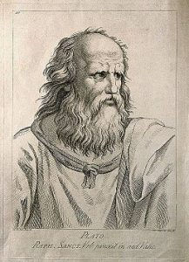
The concept of invisibility has become popular in all kinds of literature. One would have to consider Harry Potter’s cloak of invisibility, the way Dr. Faustus gained the ability to be invisible through his deal with the devil, and, of course, one really cannot discuss a ring of invisibility without discussing the One Ring, found in Tolkein’s famous Lord of the Ring trilogy.
What does this ring mean for this story? The One Ring
Below you will find the simple description of the story from Plato’s work The Republic, Book 2
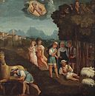Gyges was a shepherd in the service of the king of Lydia; there was a great storm, and an earthquake made an opening in the earth at the place where he was feeding his flock. Amazed at the sight, he descended into the opening, where, among other marvels, he beheld a hollow brazen horse, having doors, at which he stooping and looking in saw a dead body of stature, as appeared to him, more than human, and having nothing on but a gold ring; this he took from the finger of the dead and re-ascended.
Now the shepherds met together, according to custom, that they might send their monthly report about the flocks to the king; into their assembly he came having the ring on his finger, and as he was sitting among them he chanced to turn the collet of the ring inside his hand, when instantly he became invisible to the rest of the company and they began to speak of him as if he were no longer present. He was astonished at this, and again touching the ring he turned the collet outwards and reappeared; he made several trials of the ring, and always with the same result-when he turned the collet inwards he became invisible, when outwards he reappeared. Whereupon he contrived to be chosen one of the messengers who were sent to the court; where as soon as he arrived he seduced the queen, and with her help conspired against the king and slew him, and took the kingdom.
Suppose now that there were two such magic rings, and the just put on one of them and the unjust the other; no man can be imagined to be of such an iron nature that he would stand fast in justice. No man would keep his hands off what was not his own when he could safely take what he liked out of the market, or go into houses and lie with any one at his pleasure, or kill or release from prison whom he would, and in all respects be like a God among men. Then the actions of the just would be as the actions of the unjust; they would both come at last to the same point. And this we may truly affirm to be a great proof that a man is just, not willingly or because he thinks that justice is any good to him individually, but of necessity, for wherever anyone thinks that he can safely be unjust, there he is unjust. For all men believe in their hearts that injustice is far more profitable to the individual than justice, and he who argues as I have been supposing, will say that they are right.
If you could imagine any one obtaining this power of becoming invisible, and never doing any wrong or touching what was another’s, he would be thought by the lookers-on to be a most wretched idiot, although they would praise him to one another’s faces, and keep up appearances with one another from a fear that they too might suffer injustice.
